Printing Cultural Identity
The activity is inspired by the following artwork
in the exhibition Glorioseria at the Gregory Allicar Museum of Art
The introduction of the exhibition:
This collection is full of works mainly focused on the human body or a person’s identity in late 20th century Mexican Art. There are different kinds of paintings, drawings, and sculptures that all share a common thread. They show how Mexican Artists felt about their original historical cultures, and the oppression they faced against the long history of Spanish colonists and the beliefs that they brought to Mexico.
Title: Marquez de Sade from “Intolerance” Series
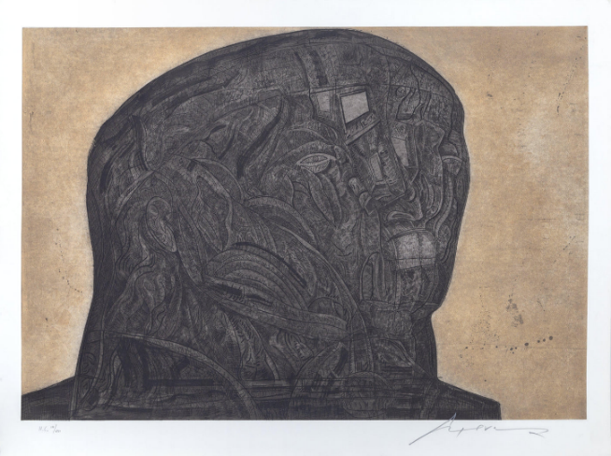 | Artwork information:  - Author: José Luis Cuevas  - Year: 1989  - Size: 35 in. x 52 in  - Material/Technique:  Etching and Aqua Tint on Paper
Some factual, historical information, or image comparison about the artwork that you can share with children:
- Cuevas was a part of the artist movement known as the “Breakaway Generation.” They turned away from painting murals or mainstream art, and instead wanted to make art that was meaningful to them. (Source: Museum tour in class)
- In this work, Cuevas made this portrait of someone he idolized. In reality, Marquez de Sade was not really someone you would want to idolize. Maybe that is why the face looks so severe?
- Printmaking a piece of artwork this size is impressive, since it is a very difficult process. He must have spent a good amount of time etching all of these details in this portrait.
- Notice how large the head is, and how small the eyes, nose and mouth are.
Possible questions to discuss with children:
- What do you see in the details of this image?
- How long do you think this took the artist to make?
- What emotions do you feel when looking at this portrait?
- We cannot see anything except the head of the person— what do you think the rest of his body looks like? Why do think Cuevas decided not to draw the rest of the body?
Now, let’s make a cultural identity print!
Materials:
-Thin, flexible foam sheets
-stack of white or tan paper
-ink pads
-stylus for making a uniform line impression. (Ballpoint pen/dull pencils can also work)
-rollers/brayers for applying ink
-tray for holding ink pads

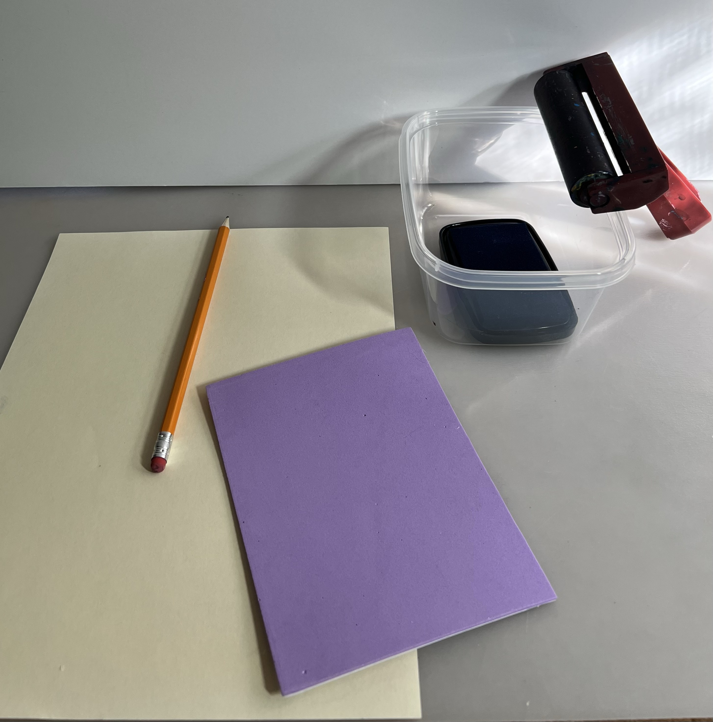 | - Each student picks up a styrofoam sheet, a pencil, a piece of tan paper, (and an idea sketch from the gallery if they made one)
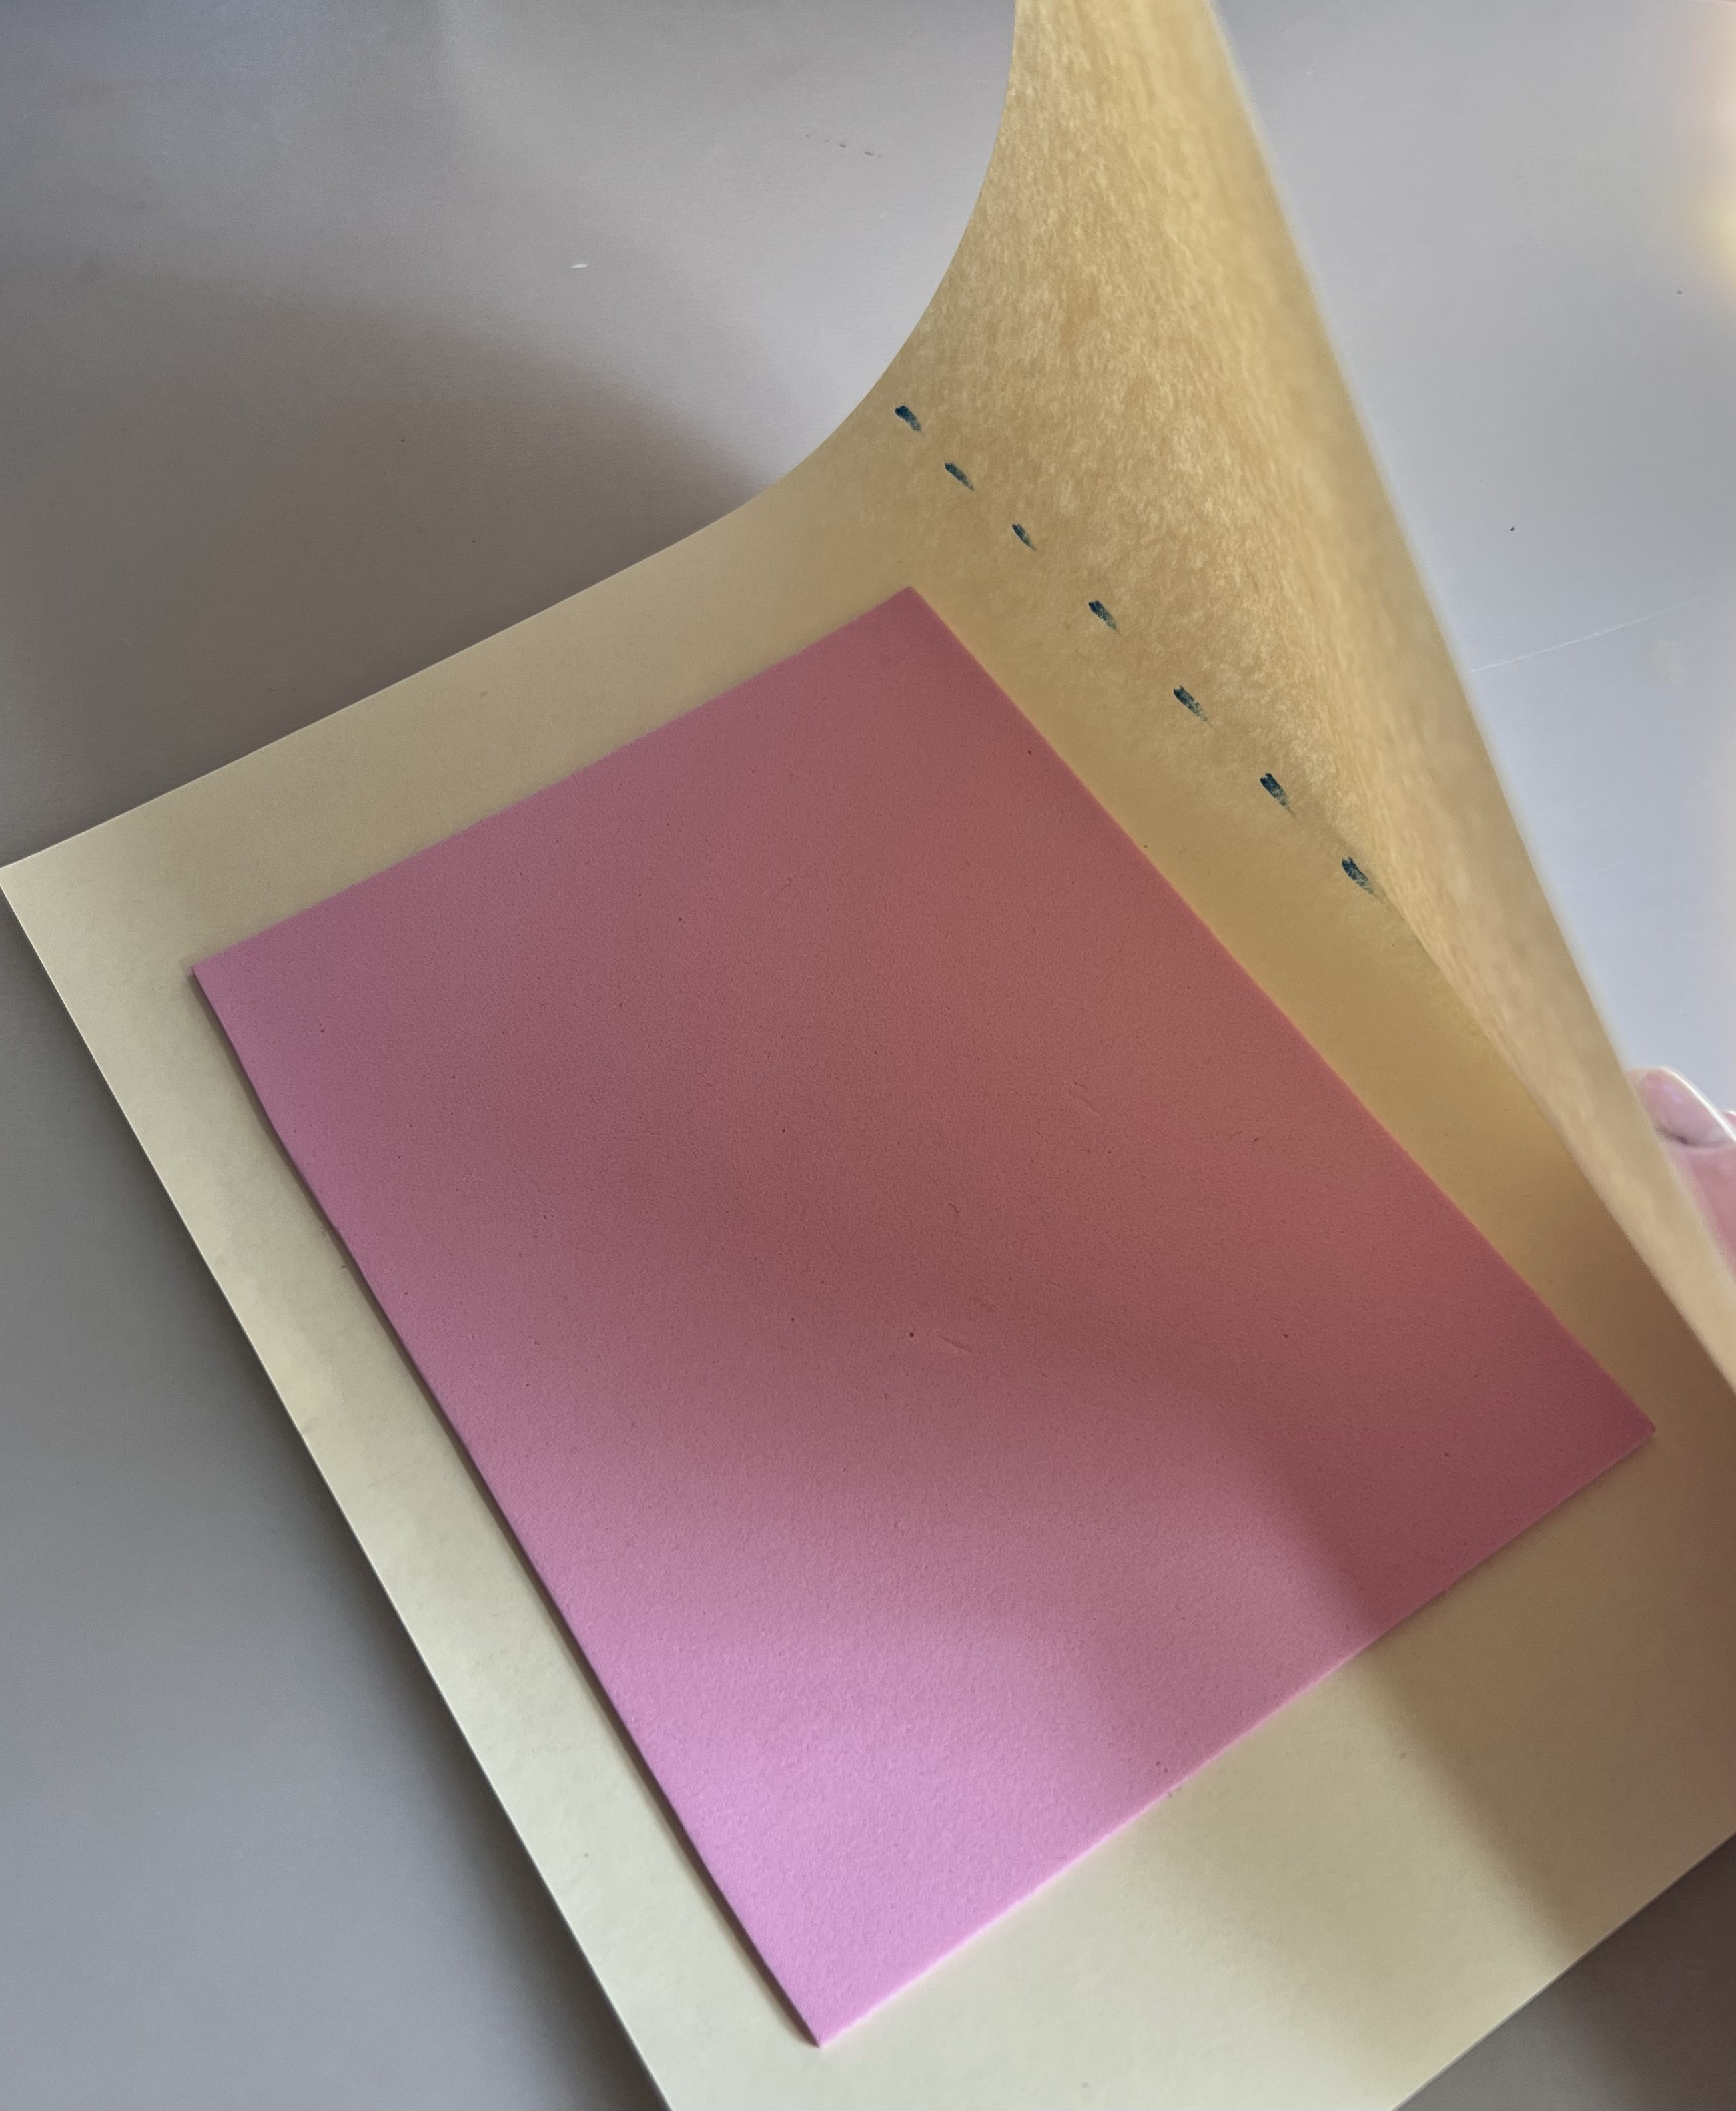  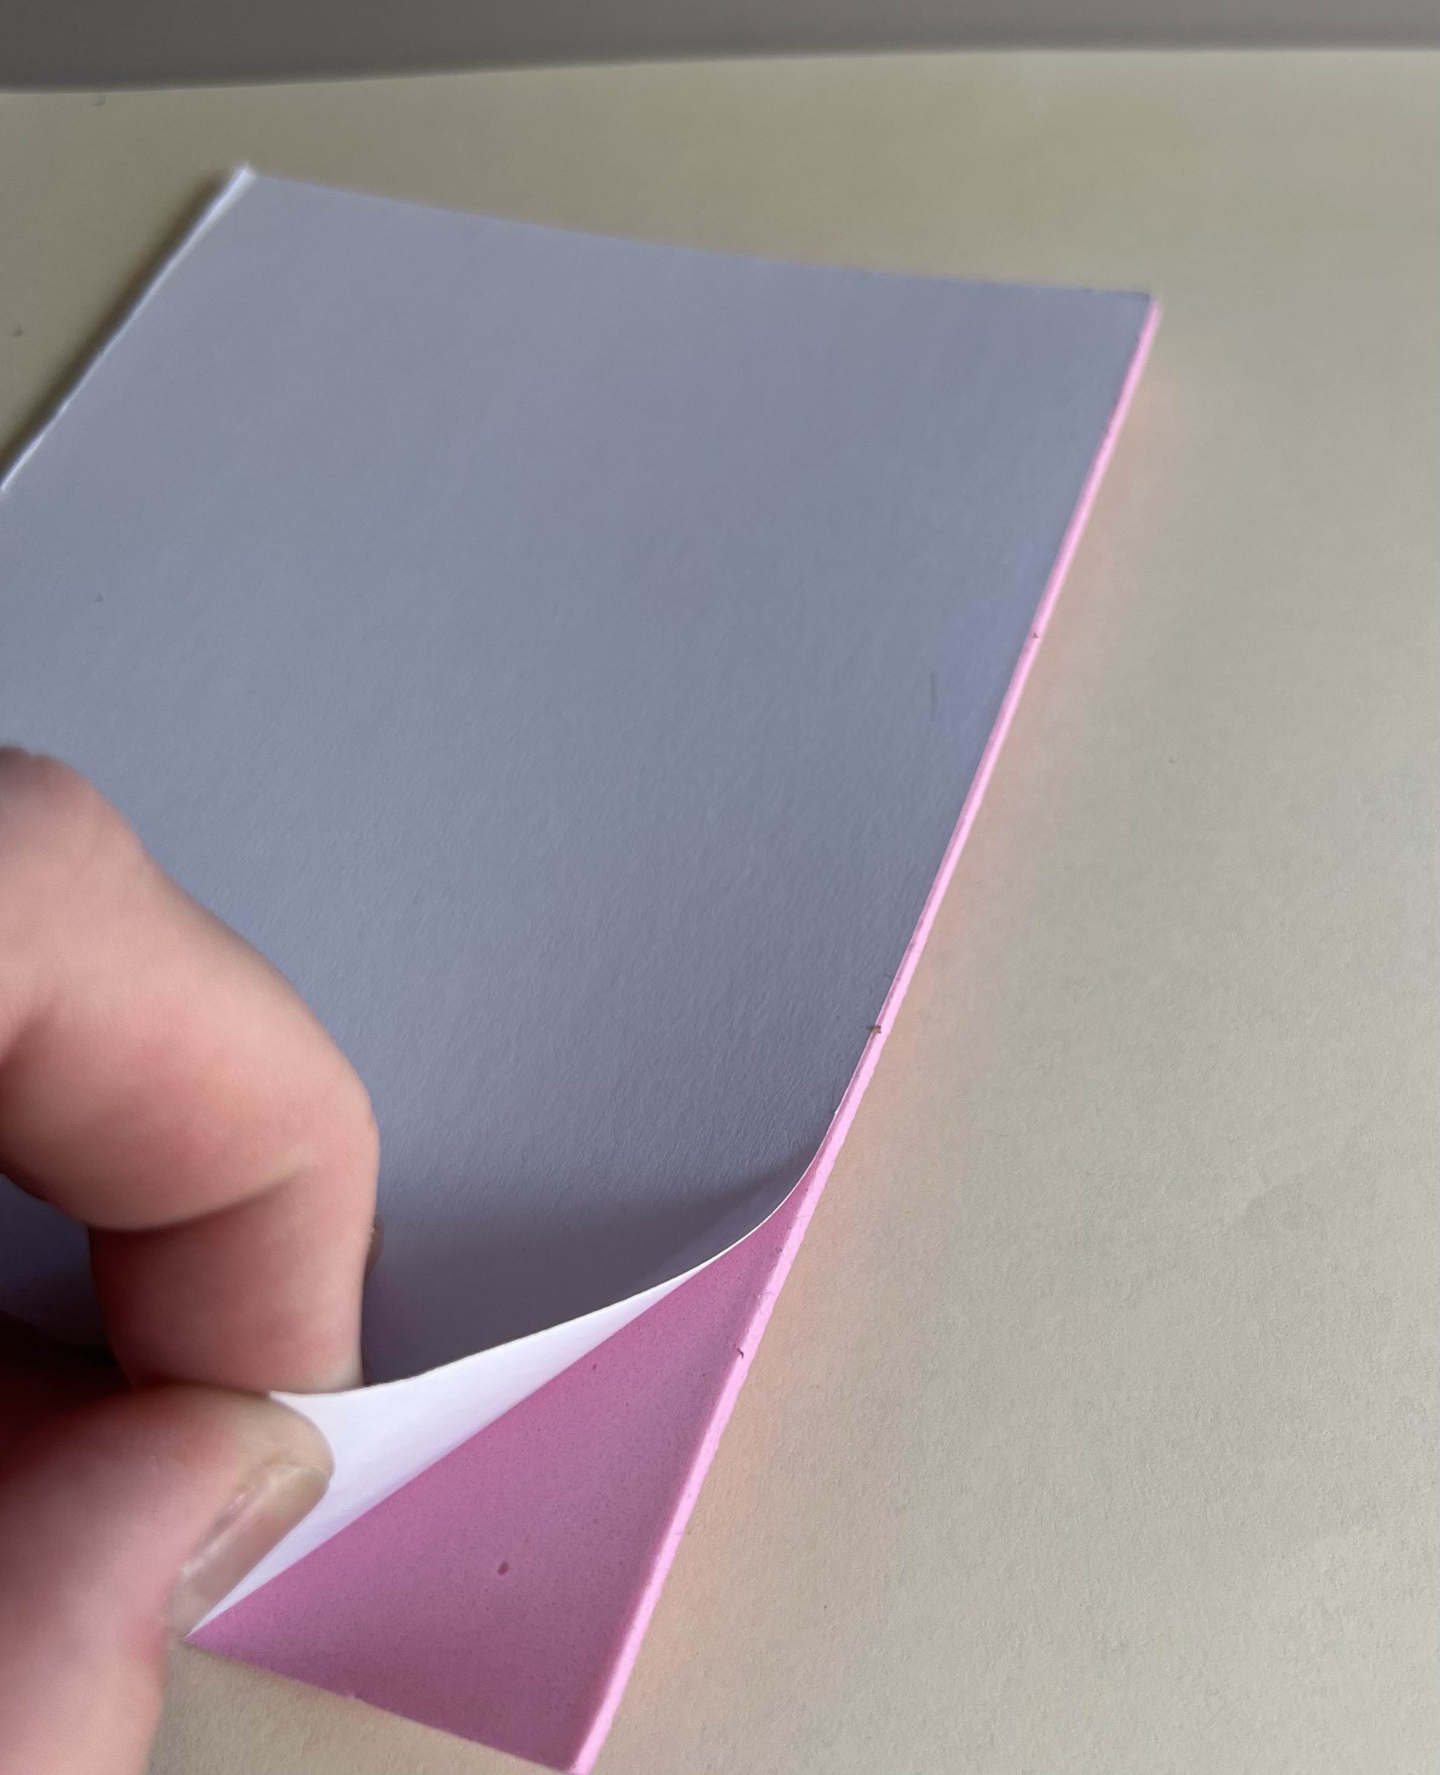 | - Children will remove backing on the foam sheet, and apply the sticky side to one side of the paper
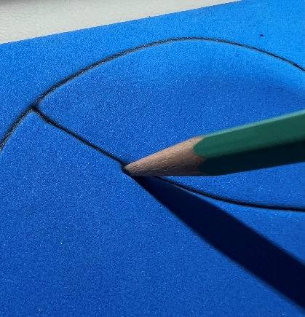
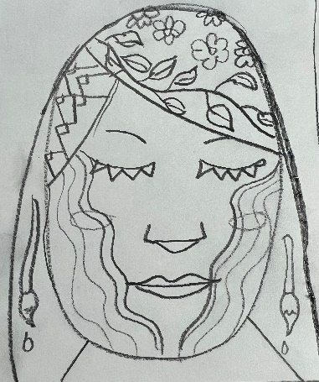
- Children who haven’t sketched any ideas, still have time to design their self-portrait with their pencil— making sure to push down firmly on the foam sheet so their lines stand out.

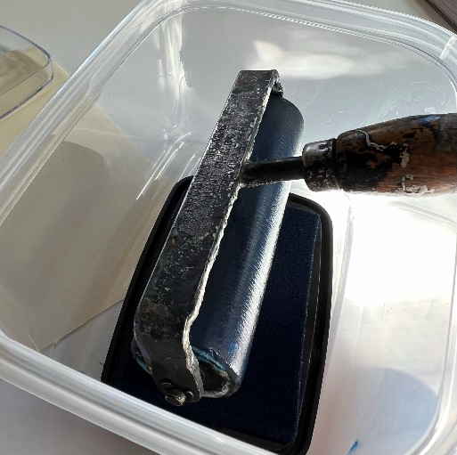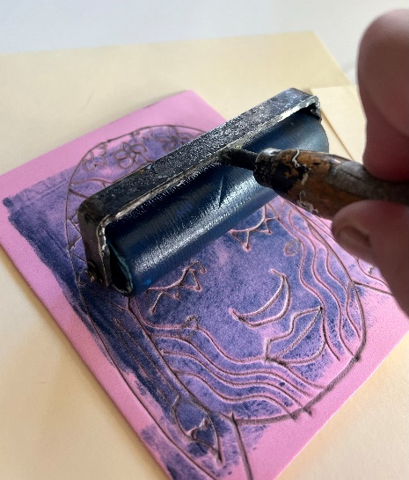
- Children will use the roller to apply ink to their foam sheet
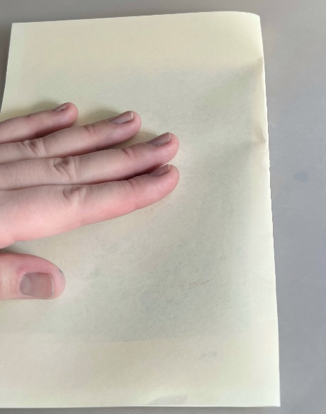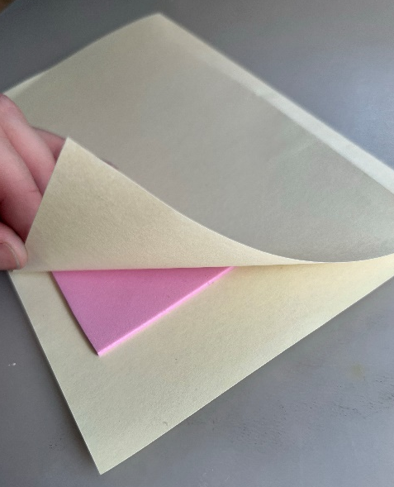
- Fold the paper in half, making sure the inner sides meet, to completely cover the inked image.

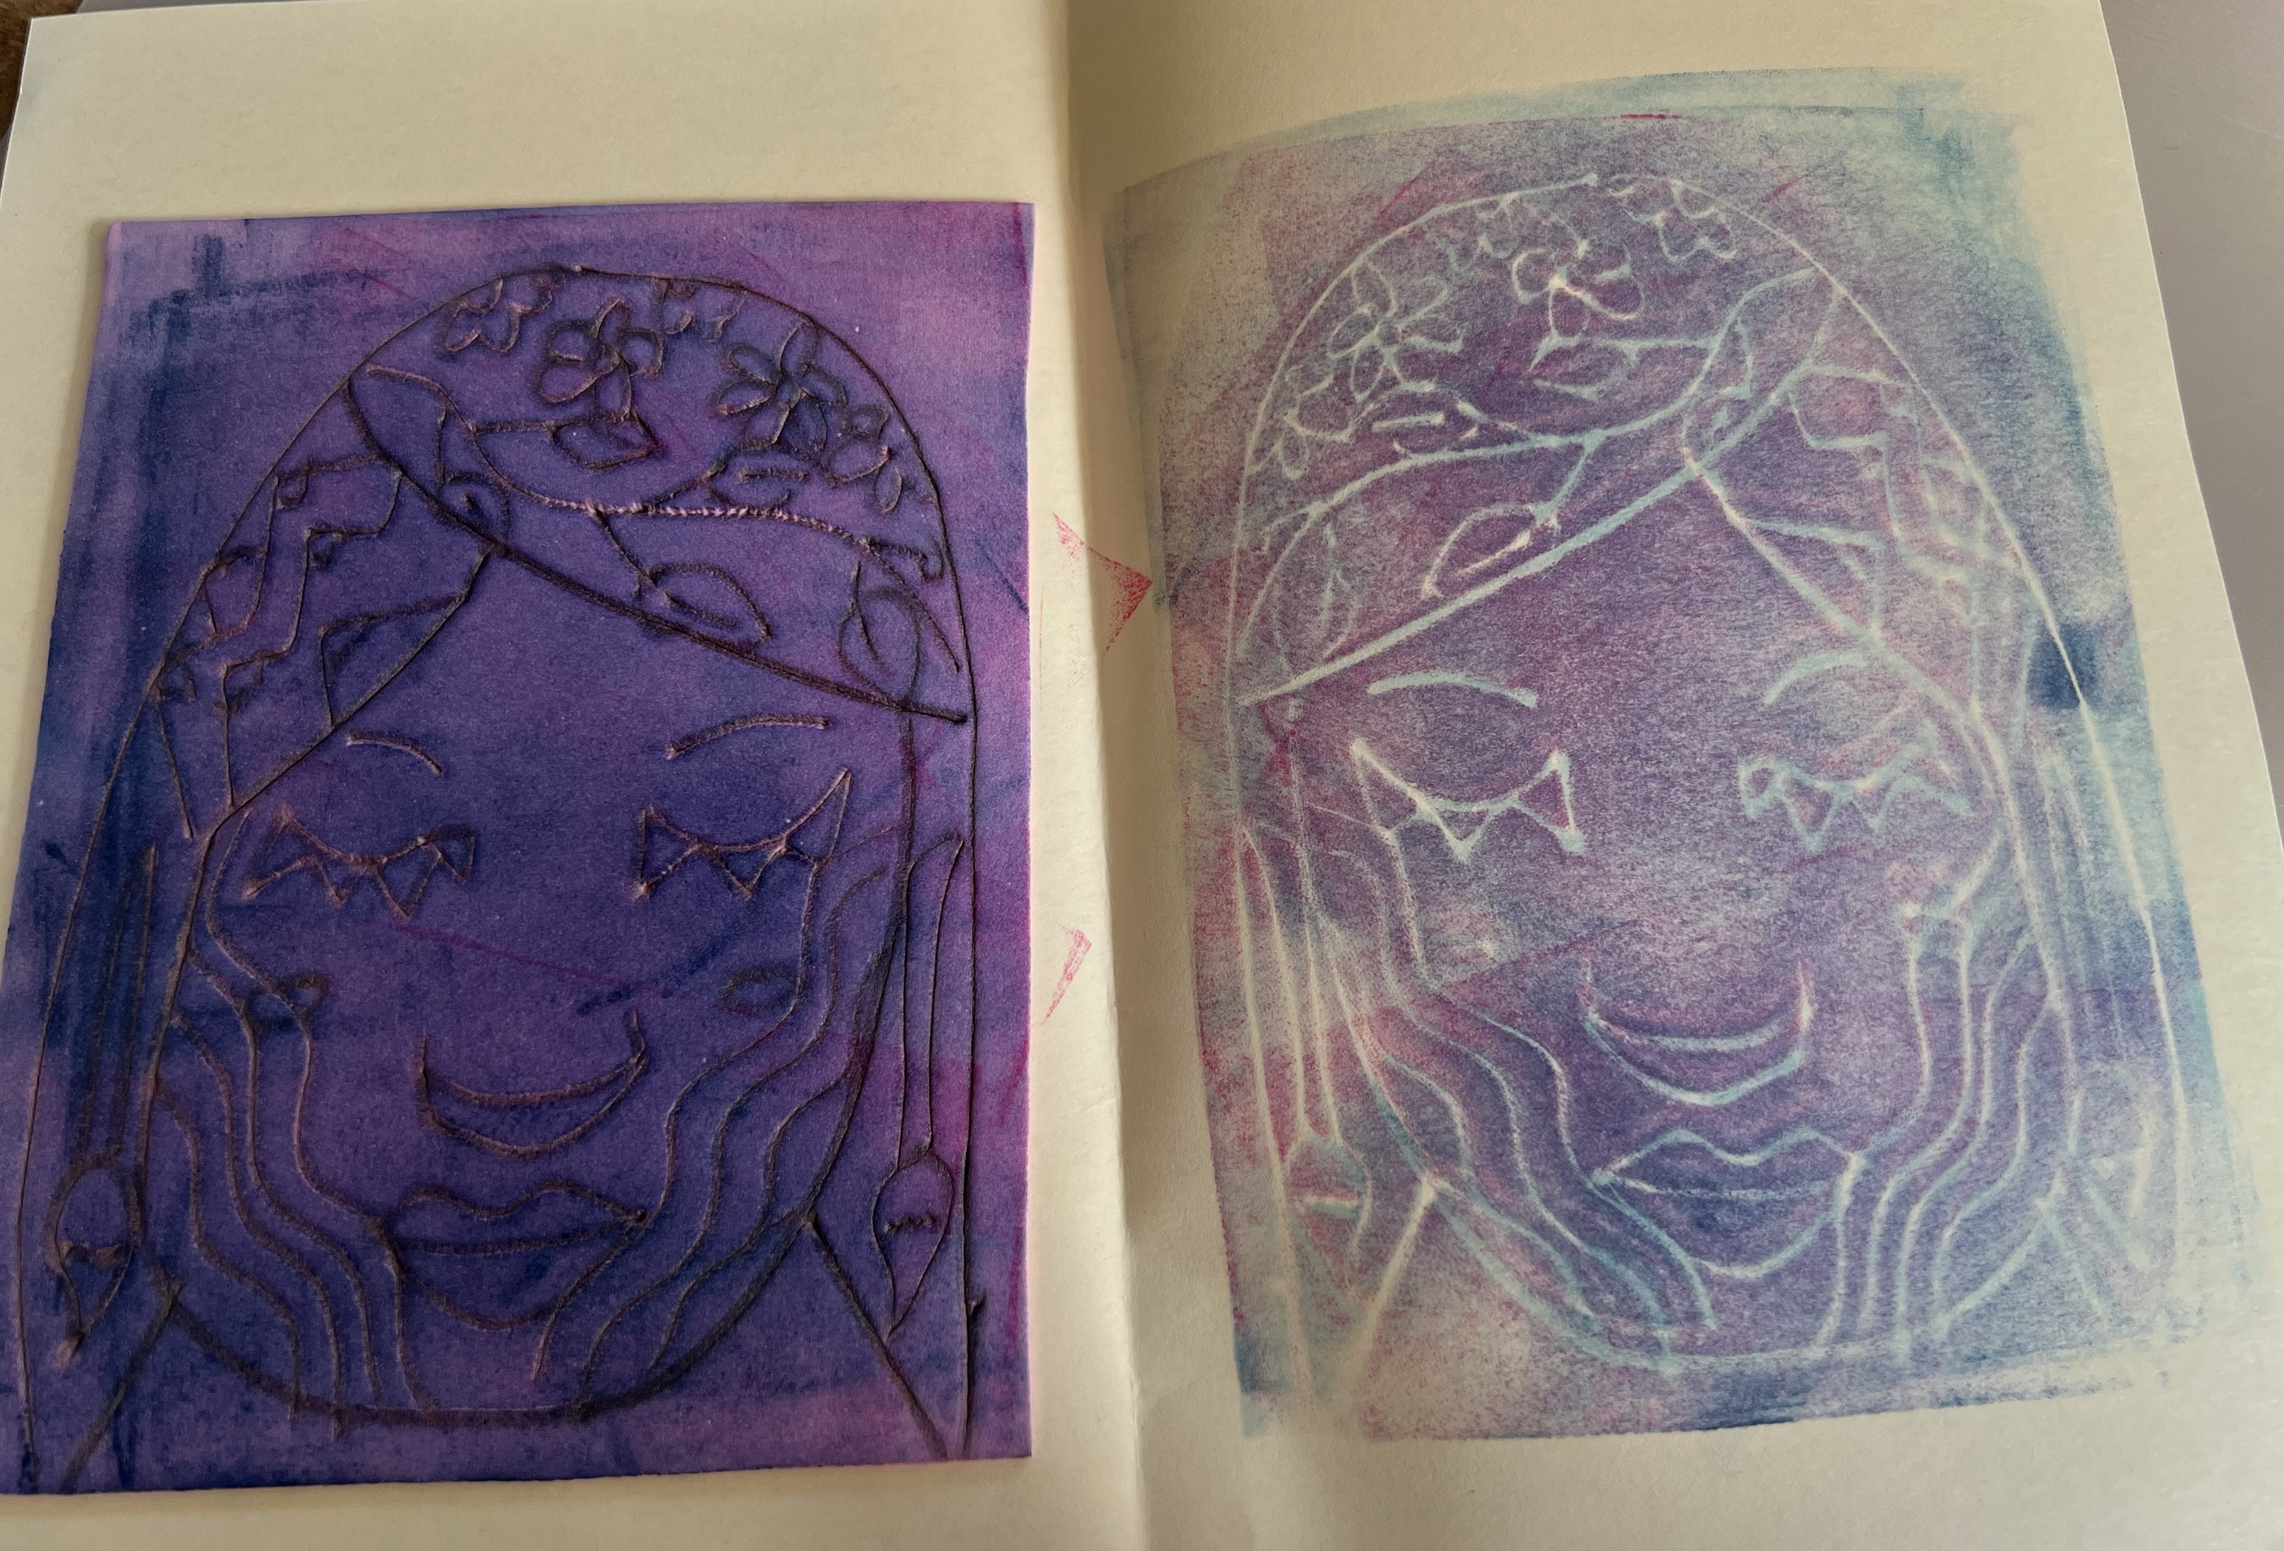
- Press firmly to make sure the ink prints on the blank side, before opening up their folded paper, and admiring your print!

