Making an Identity Kite
The activity is inspired by the following artwork
in the exhibition Glorioseria at the Gregory Allicar Museum of Art
The introduction of the exhibition:
This collection is full of works mainly focused on the human body or a person’s identity in late 20th century Mexican Art. There are different kinds of paintings, drawings, and sculptures that all share a common thread. They show how Mexican Artists felt about their original historical cultures, and the oppression they faced against the long history of Spanish colonists and the beliefs that they brought to Mexico.
Title: Papalote (kite)
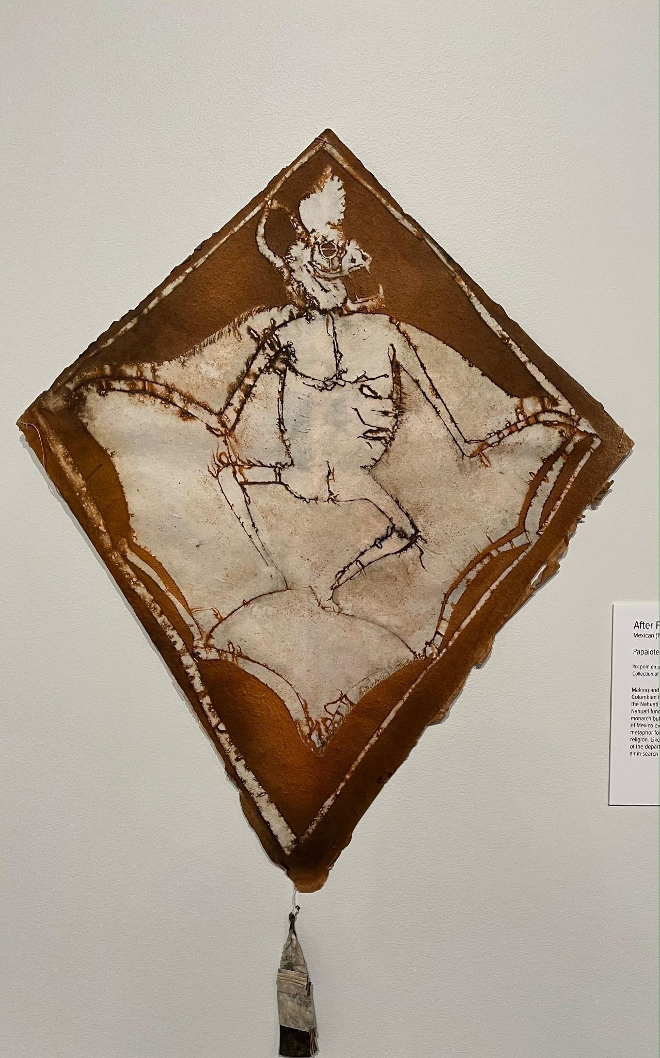 | Artwork information:  - Author: Francisco Toledo  - Year: 2005  - Size: (If Applicable)  - Material/Technique: Ink print on paper with wood and string
Some factual, historical information, or image comparison about the artwork that you can share with children:
- Making and flying kites is a pre-Columbian tradition
- The word “papalote” derived from the Nahuatl word for butterfly
- Mixtec and Nahuatl funerary art reference the migrating monarch butterflies that traverses the Valley of Mexico every winter and spring which is a possible metaphor for life and death in Mesoamerican religion
Possible questions to ask children:
- What animal do you see in this artwork? Why do you think that?
- Do you think this kite was made to fly or put on display?
- What do you learn from observing this artwork?
- What aspect of identity and culture can you see in this? Can you make any connections? Have you ever made a kite? Does your family have any traditions?
- Have you ever flown a kite? What was it like? If not, what do you think it would be like?
Now, let’s make a kite to represent your identity
Materials:
- Popsicle sticks
- Paper
- Markers
- String
- Glue (hot glue gun)
First, think about the following questions for your kite design:
- What is your favorite animal?
- What are your favorite colors?
- What are your favorite shapes?
- Are there any family/friend aspects you want to add to your kite? How will you design your kite to reflect your identity?
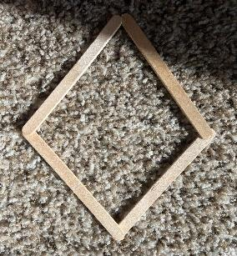 | - Children will first be handed out 4 popsicle sticks that are already glued together in the shape of a kite and a piece of kite paper.
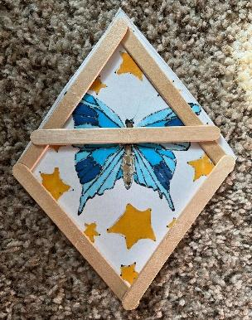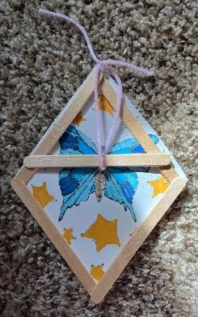  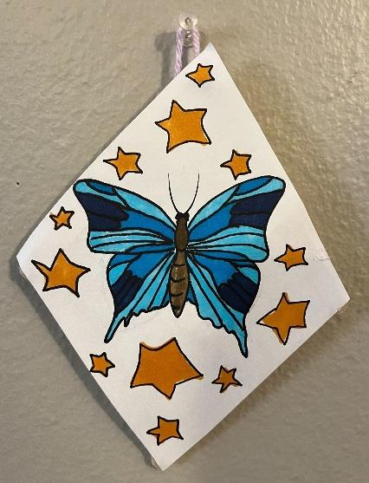 | - After finishing the design on paper, children will then glue the paper kite cut out to the popsicle sticks in the shape of a kite, glue dots will be put on the 4 black dots on the popsicle sticks already marked by the facilitator.  - Children will then glue a popsicle stick across the back of their kite so that it can be hung on a wall.  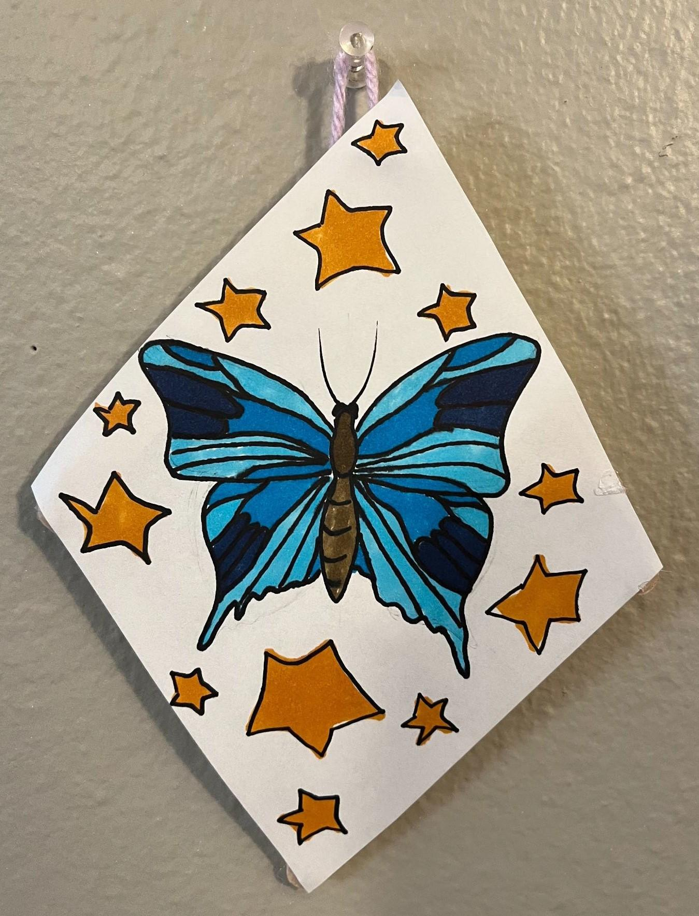  - Children will get a piece of string/yarn to tie to the back of the kits so that the kite can hang from a wall.  - Complete!

