Make a Mask to Represent You!!!
The activity is inspired by the following artwork
in the African Gallery at the Gregory Allicar Museum of Art

The introduction of the exhibition:
Our African art collection here is one of the top five in the world. The continent of Africa represents 52 countries and hundreds of cultures and languages. On this wall here, you can see modern art, made with modern techniques and materials.

Title:___Yanka___
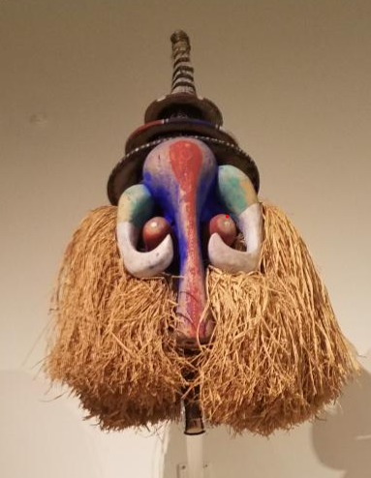 | Artwork information:  - Author: Unknown but from the Demographic republic of the Congo  - Year: 20th century  - Material/Technique: Wood with cloth, pigment, and Raﬃa
Some factual, historical information, or image comparison about the artwork that you can share with children:
Many masks across the African continent are used to give physical form to an otherworldly being, and are often regarded as the manifestation of a spiritual entity.
- Particular masks would have been worn and performed by young men, during an initiation---“Coming of age ceremony”
- Represents an elephant, not only were these masks dangerous because they are other entities. They are also a source of protection for the wearers, and elephants are this great symbol of power.
Possible questions to ask to connect children with the work:
- What does this mask remind you of/ What do you see?
- What sorts of rites of passages do we have here where we dress up?
- Why do we wear masks? Does this mask look diﬀerent than what we normally wear? Why?

Let’s Make a Mask to Represent You!

Materials:
- Pre-cut Paper plates
- Scissors
- Markers
- Hole punch
- String

Steps:
Step 1: Children will come up with ideas in their sketchbooks for animals they think are “protectors” similar to the mask that resembles an elephant (Yanka, the art inspiration)

Step 2: Children will each grab a paper plate mask that has been precut, and tied with strings
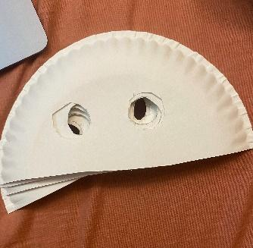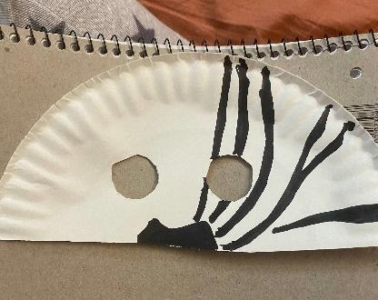
Step 3: Use other pieces of construction paper to create some fun patterns on your mask that are unique to you or are inspired from the mask, Yanka.
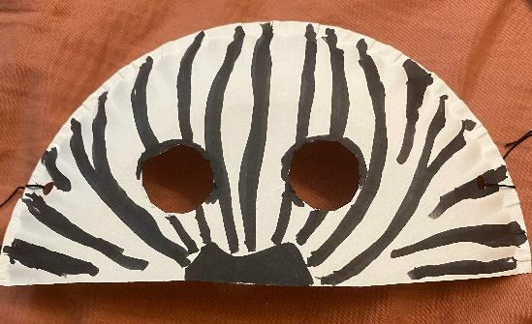
Step 4: Utilize tapes to stick your raffia ribbon on the back of your mask.
Step 5: Tie the strings on your head to wear the mask. Then you are all done!
Finished example: 