Expressing the Self through Textures
The activity is inspired by the following artwork
in the exhibition Glorioseria at the Gregory Allicar Museum of Art

The introduction of the exhibition:
This collection is full of works mainly focused on the human body or a person’s identity in late 20th century Mexican Art. There are different kinds of paintings, drawings, and sculptures that all share a common thread. They show how Mexican Artists felt about their original historical cultures, and the oppression they faced against the long history of Spanish colonists and the beliefs that they brought to Mexico.

Title: Pedro
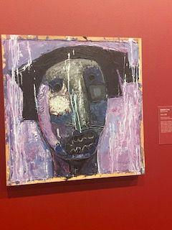 | Artwork information:  - Author: Vladimir Cora  - Year: 2002  - Material/Technique: Oil & Resin on Canvas
Some factual, historical information, or image comparison about the artwork that you can share with children:
- This piece, as well as many of Cora’s other works are “neo figurative”, or Nueva Figuration- which is a Latin American form of figurative art incorporating abstraction and traditional figurative techniques
- Cora likes to create art very spontaneously, seen here, with rich colors and textures. He doesn’t start with a plan before he paints
- This piece may be a self-portrait, as the figure appears similar to the artist. Cora uses color (black and violet) and shapes & lines to create uneasy, almost anxious feelings in the piece
Possible questions to discuss with children:
- What details can you see in this piece?
- What do you think Cora was trying to say in this piece?
- How do the colors and shapes make you feel? Why?
- What does this artwork say about the artist’s identity? How can you tell?

Now, let’s create your self-portrait by creating some textures!
The materials:
8x6in colored paper, oil pastels, found/secondhand carving tools- plastic forks, wooden clay tools, wooden/metal utensils, etc., marker
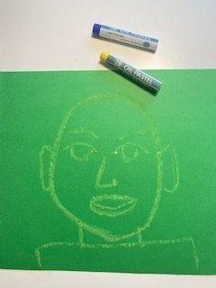

Step 1: We will start by drawing self-portraits using 2-3 colors of oil pastels. We will start with an oval for the head, shapes like circles, triangles and rectangles for facial features, and lines for the neck and shoulders.

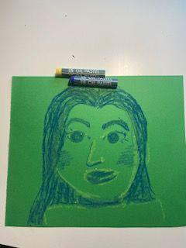

Step 2: Now we will color in our portraits using our few colors. We don’t have to worry about making it perfect, we just want to fill the shapes.

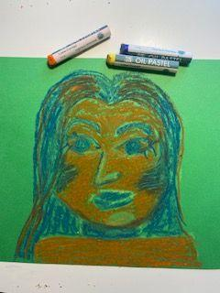

Step 3: With 2 different colors, we will color in the background, trying to fill in as much space as possible. We will not worry about blending or perfection here, be spontaneous!

Step 4: Using our carving tools, we will now carve the details of our portraits, and add texture/design to the background using line and shape. This carving technique will reveal the color of the paper underneath.
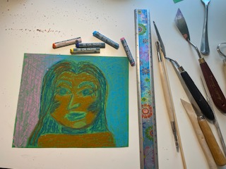

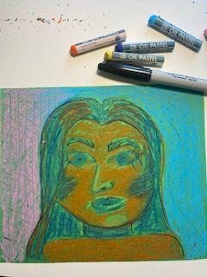
Step 5: Finally, we can finalize the details of our self-portrait with a black marker or pastel. We can outline shapes, highlight accents, or add designs to add depth to our portraits.

