Creating an Identity Key Chain
The activity is inspired by the following artwork
in the African Gallery at the Gregory Allicar Museum of Art

The introduction of the exhibition:
Our African art collection here is one of the top five in the world. The continent of Africa represents 52 countries and hundreds of cultures and languages. On this wall here, you can see modern art, made with modern techniques and materials.

Title: Masai Beadwork necklaces from Kenya
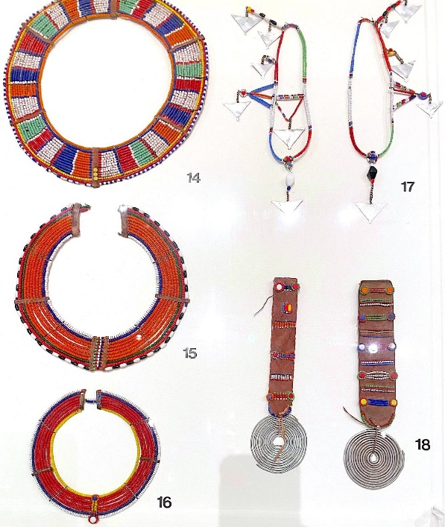 | Artwork information:  - Unknown Maasai Artist Emankeki oo Muatat Kenya  - 20th Century, Glass beads, metal wire and leather
Some factual, historical information, or image comparison about the artwork that you can share with children:
- Beadwork is about identity. These colors all signify something: White signifies the milk, Green signifies the grasslands that feed the cows and goats.
- Southeastern Africa- open grasslands, agricultural societies- identifiers of age, family name
  - Jewelry is about identity and culture. Some examples of this in our western culture are:
- Wedding rings- To show that you are married
- Crowns- to show if the person is a king, queen, princess, prince Locket- as a special item to show loved ones
- Rings- celebrate something like an anniversary, to signify graduating from college: class ring.
- Necklace- can tell you their religion.
- Diamond earrings, necklace- What could that tell you about someone? What would you think of a person that wears lots of diamonds?

Possible questions to ask children:
- When do we wear jewelry and why?
- What colors do we see here? What might these colors mean?
- Where are these pieces worn and by whom?
- Why do you think these necklaces are different?

Now, let’s make an animal key chain using color beads to represent you!
When we grow up, we get keys. This is a sort of rite of passage in our culture. When you see someone that has a lot of keys what could that mean? Now we are going to be making our own keychains! Using the activity sheet, choose two to three colors that mean something to you.
- Why do these colors feel special?
- What emotions do these colors make you feel?
- While we make these- let's also think of what animal we would be and why?
- Why did you choose this animal for yourself?
Materials:
- Reflex cord
- Key ring
- Beads (Letter, animal and colored beads)
- Scissors
Steps
 | 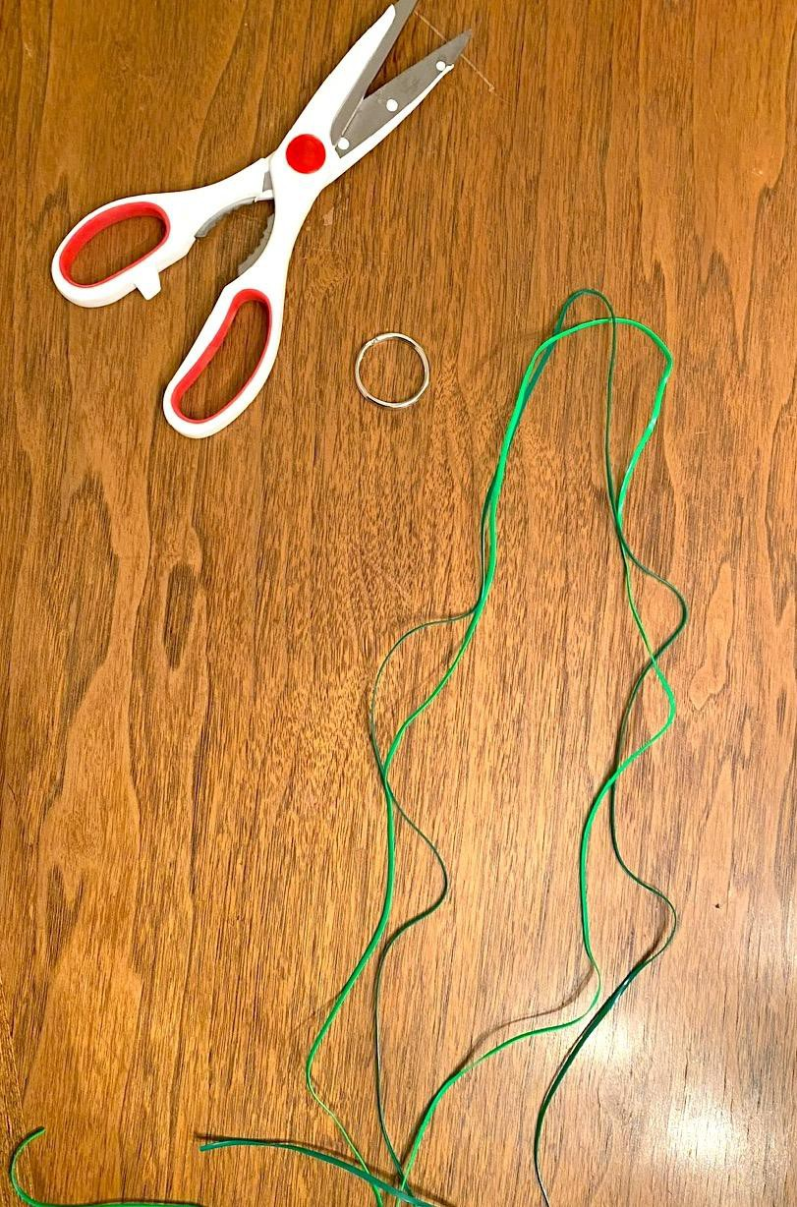 |  | 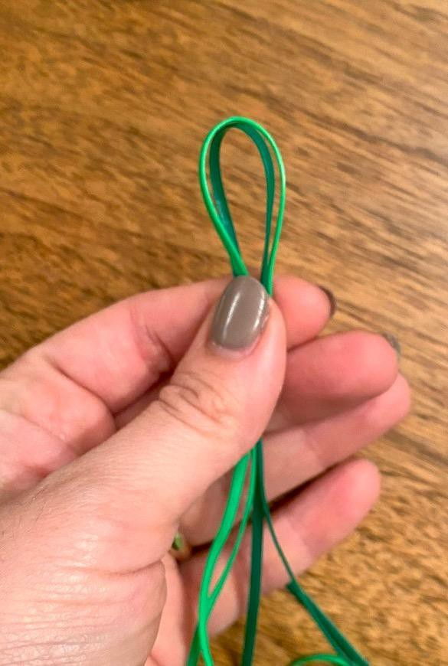 |  | 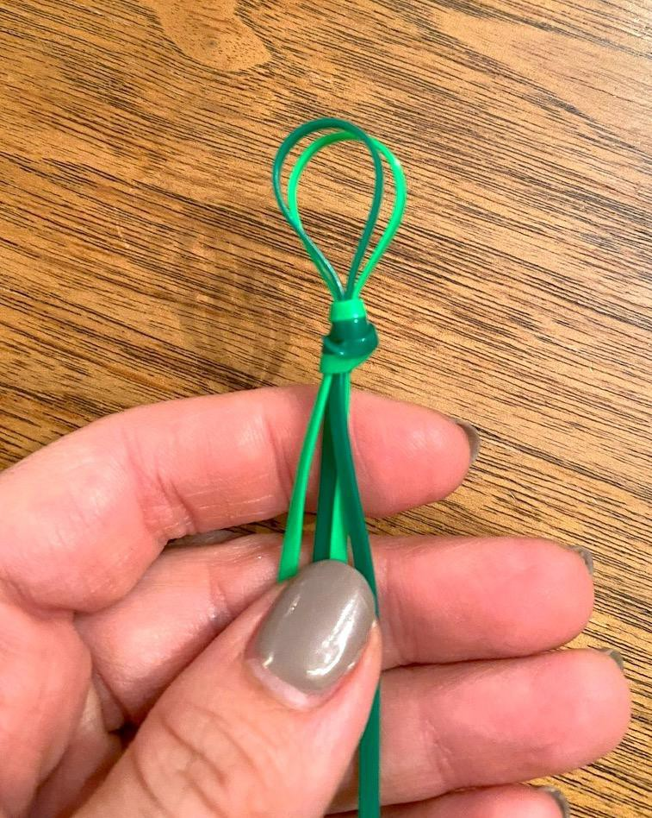 | 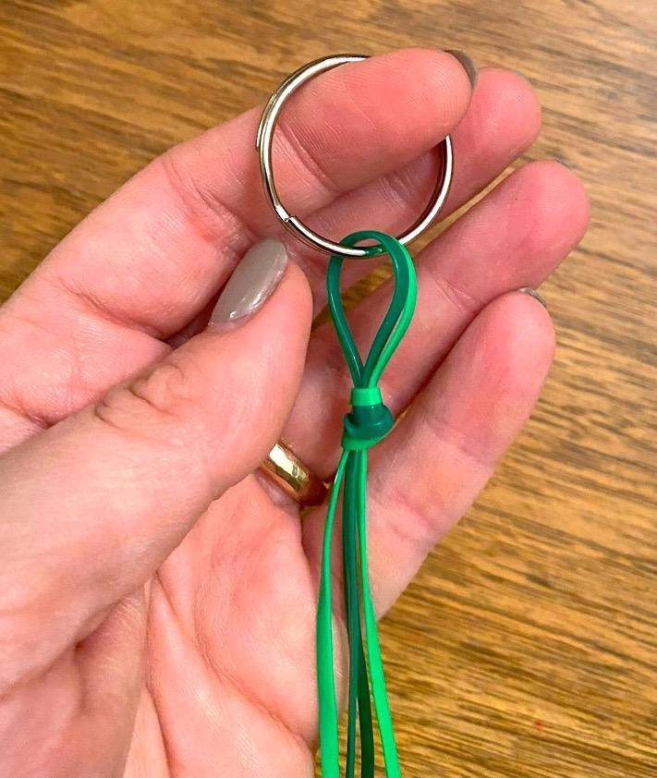
 | STEP 1: pick out your two cord colors and keyring. Pick out colors that mean something to you- how do these colors represent you? |  | STEP 2: Fold your cord in half and find the middle point |  | STEP 3: Make a loop and then knot. Pull tight | STEP 4: Slide the loop onto the keyring
 | 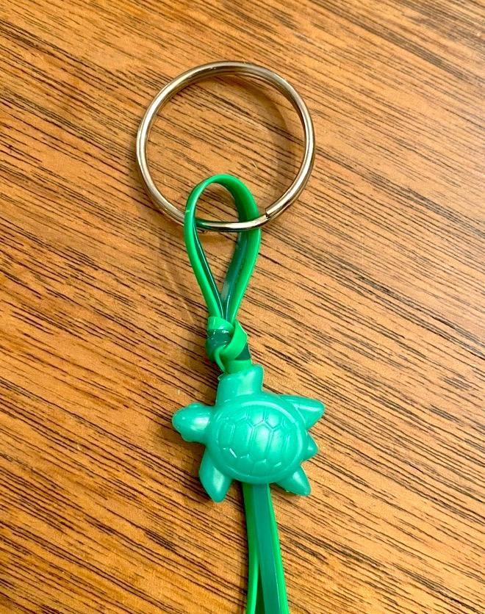 |  | 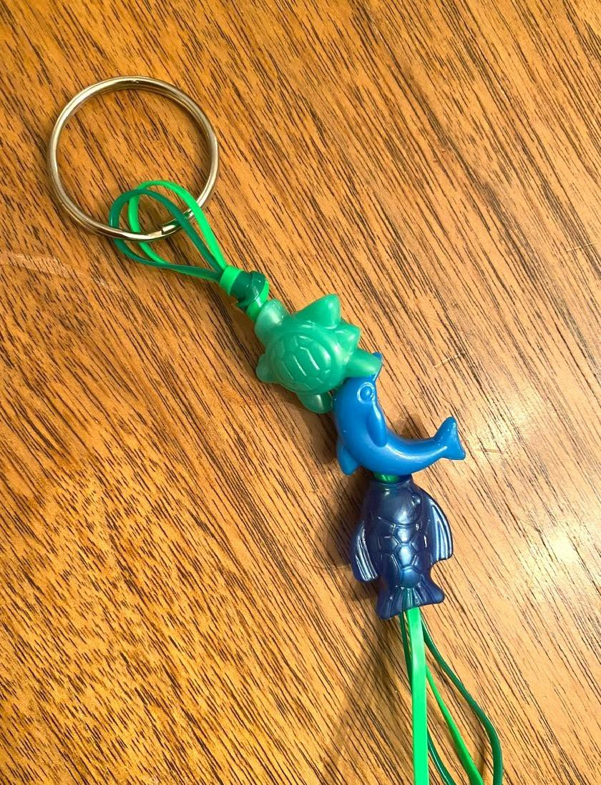 |  | 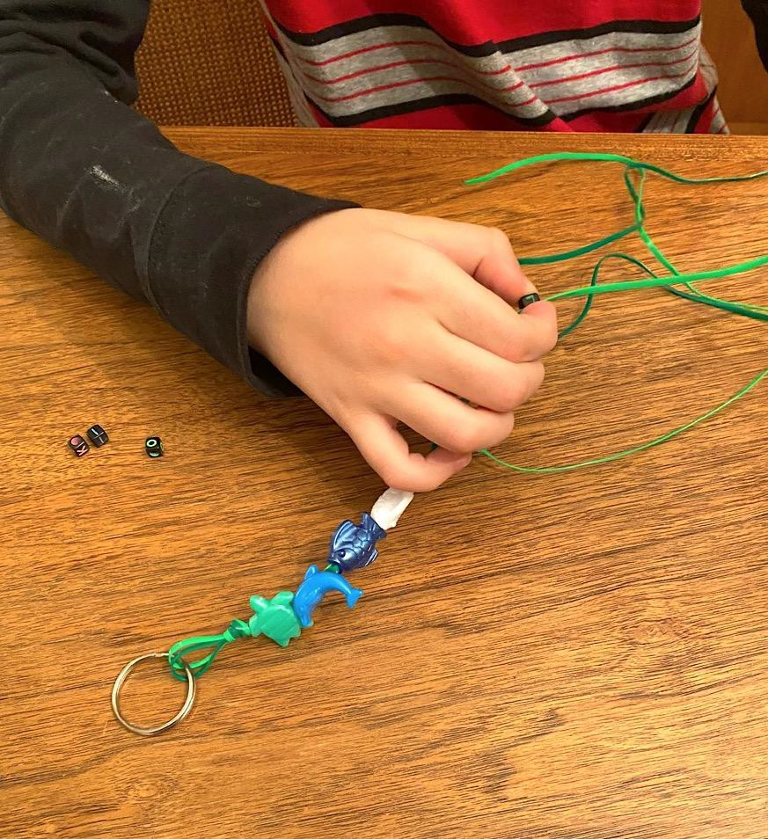 | 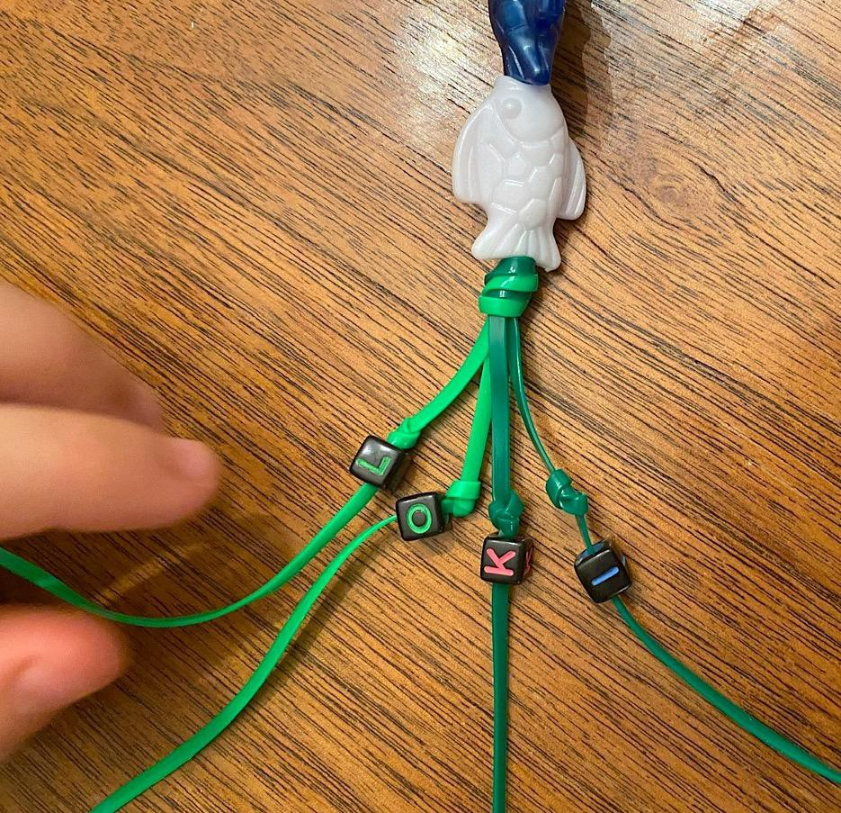
 | STEP 5: Start adding your beads. Note:  Different beads will accept a different amount of cord. |  | STEP 6: Continue adding beads that reflect what you like or that you find cool |  | STEP 7: You may want to add letter beads. This can be your nickname, initials- up to you! | STEP 8: Some beads might need a double knot to secure them
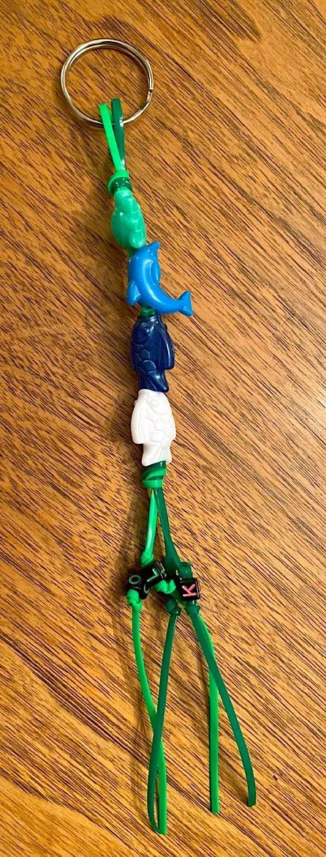 |  | 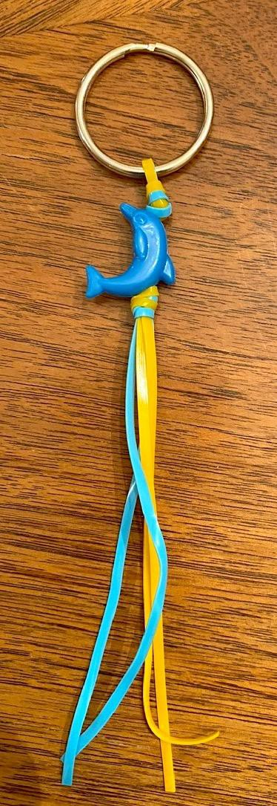 |  | 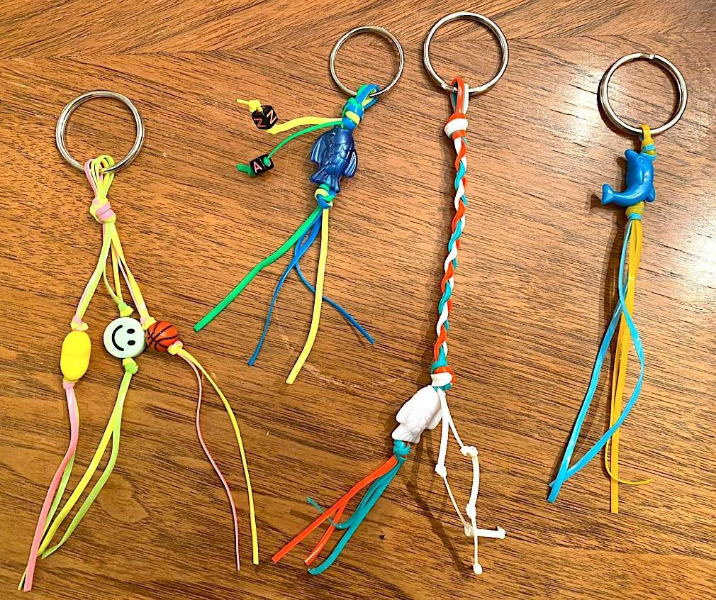
STEP 9: This is the finished keyring! Yours will look unique to you and what you like! |  | STEP 10: This is an example with just one bead and different colors. |  | STEP 11: These are examples of different variations that you can do! Braid it! Add another color! These are as unique and fun as you are!

